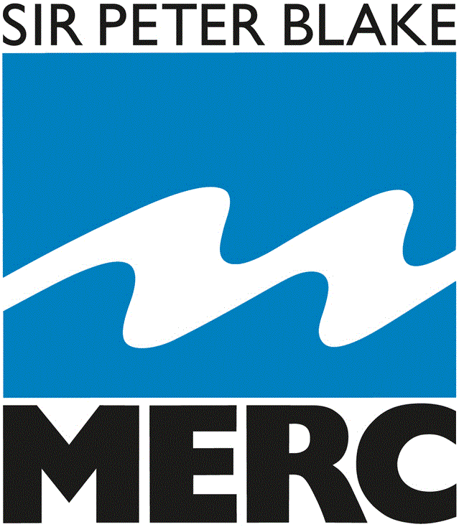 RESIDENTIAL OVERVIEW
MERC is committed to designing and delivering quality experiences that align to individual client groups.
The following descriptions provide insight into how specific activities may combine to produce a holistic ‘experience’, pursuing successful outcomes having determined purposeful objectives.
Moana Mission (Deep Water Survival): Boating experience in which participants develop skills and gain knowledge of important equipment and sensible practice that enables purposeful, pleasurable participation with the sea and a range of craft.
Moana Mission (Sail): Experiencing sailing from the perspective of skill development, understanding of sensible boating practice, the ability to travel, explore and gain knowledge of places and people. Stories of formation of the land and the importance of all the creatures that exist in and around the ocean and the impact humans have exist within this experience.
Moana Mission (Castaway): A challenge in which people are presented with a scenario of being stranded and in need of scavenging materials to construct a craft that will enable everybody to travel to a place of refuge. Items such as floats, barrels, spar, poles ropes and sheets are the items made available for people to create a vessel on which everyone can travel. The opportunity exists in this experience for people to identify and share thoughts concerning tasks, which when actioned, will determine the outcome and an experience that is rich to review with regard to factors associated with problem solving and working collaboratively towards a specific goal.
Moana Mission: Hoe (Paddle): Engaging with a range of craft that are human powered with paddles, developing skills that enable effective maneuvering and travel. Development of awareness of responsibility to oneself and to others in a group. Recognising and tolerating different levels of competency and confidence are an important part of these experiences. Close connections to other cultures are inherent in paddling. People from different places for centuries have worked and recreated on the water in this way. Stories of formation of the land and the importance of all the creatures that exist in and around the ocean and the impact humans have exist within this experience.
Whenua Mission: Ropu Wero (Group Challenge): Dynamic group problem solving challenges, promoting tolerance, sharing ideas, decision making, resilience and consideration of other people’s ideas in pursuit of success.
Whenua Mission: Survival & Projectiles: Exploring the primary needs for human survival, shelter, warmth, hunting and foraging for food and water, flora and fauna knowledge and effective community contributions. Recognising one’s ability to look after oneself and the importance of quality relationships is an inherent theme.
Whenua Mission: Teitei (high): Experiences in which height, challenges perceptions of comfort and control, in which people learn about managing their own state of mind and body and the welfare of others. Specific systems are employed that enable the perceived threat to be overcome, however people often require significant courage and determination to be successful. It is very important in these activities to highlight that people have very different perceptions and success will vary for different individuals The experiences overtly recognises that it is normal to be anxious in times of uncertainty, however through employing effective strategies it is possible to achieve outcomes that may initially appear in surmountable. Scaling heights (going up) and descending (coming down) from height are both options.
Group options: to be negotiated and coordinated within groups and between groups as a conclusion to a visit. The idea is to create an opportunity to share and consider different views, consider important factors such as weather and sea condition and to make a decision that is mindful of everybody in a group but also recognizes that fair and reasonable outcomes require compromise. An opportunity to sample decision making methods from a range of options including an: arbitrary dice roll, a democratic vote, and executive decision from an appointed representative (student, teacher, MERC staff member)

